|  |
| --- |
| 1. |
| 2. |
| 3. |
| 4. |
| 5. |
| 6. |
| 7. |
| 8. |
| 9. |
| 10. |

10.

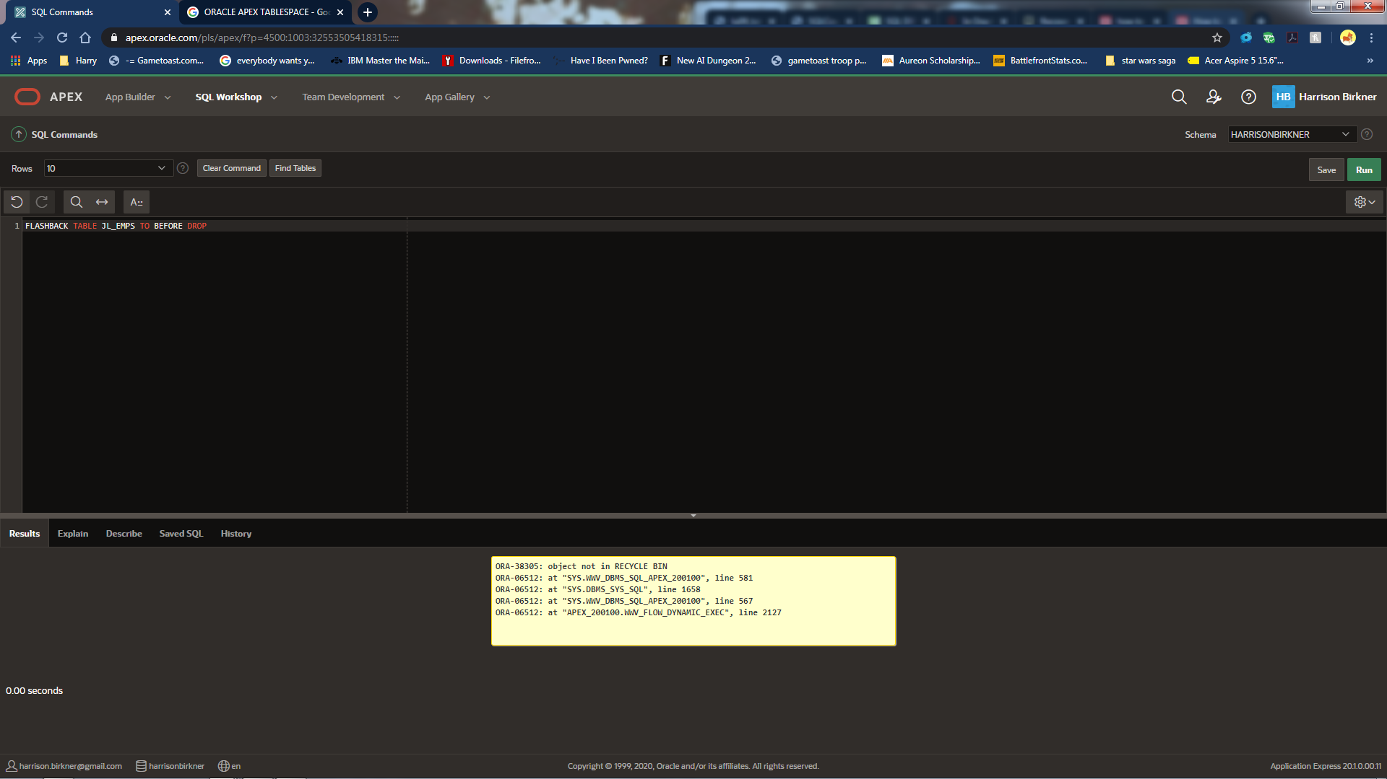

I got this error when I tried to flashback the JLEmps table. I looked into it and it might something to do with apex using system as the default tablespace. I was not sure how to remedy the issue.